**Title: classify the Size_Categorie using SVM**

> library(caret)

Loading required package: lattice

Loading required package: ggplot2

> library(ggplot2)

> library(psych)

Attaching package: ‘psych’

The following objects are masked from ‘package:ggplot2’:

%+%, alpha

Warning message:

package ‘psych’ was built under R version 4.0.3

> library(kernlab)

Attaching package: ‘kernlab’

The following object is masked from ‘package:psych’:

alpha

The following object is masked from ‘package:ggplot2’:

alpha

Warning message:

package ‘kernlab’ was built under R version 4.0.3

> forest <- read.csv(file.choose())

> View(forest)

> str(forest)

'data.frame': 517 obs. of 31 variables:

$ month : chr "mar" "oct" "oct" "mar" ...

$ day : chr "fri" "tue" "sat" "fri" ...

$ FFMC : num 86.2 90.6 90.6 91.7 89.3 92.3 92.3 91.5 91 92.5 ...

$ DMC : num 26.2 35.4 43.7 33.3 51.3 ...

$ DC : num 94.3 669.1 686.9 77.5 102.2 ...

$ ISI : num 5.1 6.7 6.7 9 9.6 14.7 8.5 10.7 7 7.1 ...

$ temp : num 8.2 18 14.6 8.3 11.4 22.2 24.1 8 13.1 22.8 ...

$ RH : int 51 33 33 97 99 29 27 86 63 40 ...

$ wind : num 6.7 0.9 1.3 4 1.8 5.4 3.1 2.2 5.4 4 ...

$ rain : num 0 0 0 0.2 0 0 0 0 0 0 ...

$ area : num 0 0 0 0 0 0 0 0 0 0 ...

$ dayfri : int 1 0 0 1 0 0 0 0 0 0 ...

$ daymon : int 0 0 0 0 0 0 1 1 0 0 ...

$ daysat : int 0 0 1 0 0 0 0 0 0 1 ...

$ daysun : int 0 0 0 0 1 1 0 0 0 0 ...

$ daythu : int 0 0 0 0 0 0 0 0 0 0 ...

$ daytue : int 0 1 0 0 0 0 0 0 1 0 ...

$ daywed : int 0 0 0 0 0 0 0 0 0 0 ...

$ monthapr : int 0 0 0 0 0 0 0 0 0 0 ...

$ monthaug : int 0 0 0 0 0 1 1 1 0 0 ...

$ monthdec : int 0 0 0 0 0 0 0 0 0 0 ...

$ monthfeb : int 0 0 0 0 0 0 0 0 0 0 ...

$ monthjan : int 0 0 0 0 0 0 0 0 0 0 ...

$ monthjul : int 0 0 0 0 0 0 0 0 0 0 ...

$ monthjun : int 0 0 0 0 0 0 0 0 0 0 ...

$ monthmar : int 1 0 0 1 1 0 0 0 0 0 ...

$ monthmay : int 0 0 0 0 0 0 0 0 0 0 ...

$ monthnov : int 0 0 0 0 0 0 0 0 0 0 ...

$ monthoct : int 0 1 1 0 0 0 0 0 0 0 ...

$ monthsep : int 0 0 0 0 0 0 0 0 1 1 ...

$ size_category: chr "small" "small" "small" "small" ...

> table(forest$size_category)

large small

139 378

> ggplot(data = forest)+geom_histogram(mapping = aes(x=forest$area),binwidth = 50)

Warning message:

Use of `forest$area` is discouraged. Use `area` instead.

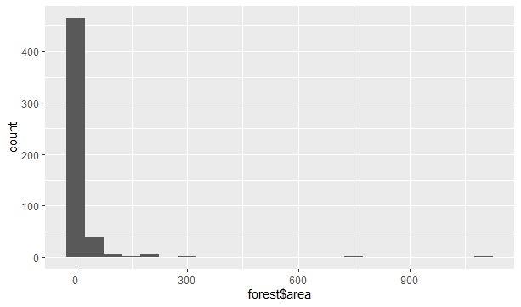

> ggplot(data = forest)+geom_bar(mapping = aes(x=forest$size_category))

Warning message:

Use of `forest$size_category` is discouraged. Use `size_category` instead.

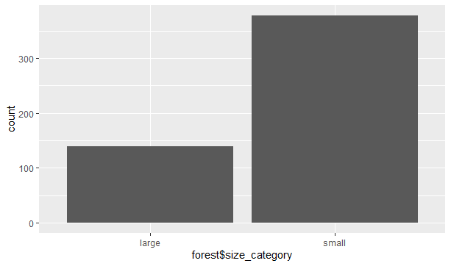

> summary(forest)

month day FFMC DMC

Length:517 Length:517 Min. :18.70 Min. : 1.1

Class :character Class :character 1st Qu.:90.20 1st Qu.: 68.6

Mode :character Mode :character Median :91.60 Median :108.3

Mean :90.64 Mean :110.9

3rd Qu.:92.90 3rd Qu.:142.4

Max. :96.20 Max. :291.3

DC ISI temp RH wind

Min. : 7.9 Min. : 0.000 Min. : 2.20 Min. : 15.00 Min. :0.400

1st Qu.:437.7 1st Qu.: 6.500 1st Qu.:15.50 1st Qu.: 33.00 1st Qu.:2.700

Median :664.2 Median : 8.400 Median :19.30 Median : 42.00 Median :4.000

Mean :547.9 Mean : 9.022 Mean :18.89 Mean : 44.29 Mean :4.018

3rd Qu.:713.9 3rd Qu.:10.800 3rd Qu.:22.80 3rd Qu.: 53.00 3rd Qu.:4.900

Max. :860.6 Max. :56.100 Max. :33.30 Max. :100.00 Max. :9.400

rain area dayfri daymon

Min. :0.00000 Min. : 0.00 Min. :0.0000 Min. :0.0000

1st Qu.:0.00000 1st Qu.: 0.00 1st Qu.:0.0000 1st Qu.:0.0000

Median :0.00000 Median : 0.52 Median :0.0000 Median :0.0000

Mean :0.02166 Mean : 12.85 Mean :0.1644 Mean :0.1431

3rd Qu.:0.00000 3rd Qu.: 6.57 3rd Qu.:0.0000 3rd Qu.:0.0000

Max. :6.40000 Max. :1090.84 Max. :1.0000 Max. :1.0000

daysat daysun daythu daytue daywed

Min. :0.0000 Min. :0.0000 Min. :0.000 Min. :0.0000 Min. :0.0000

1st Qu.:0.0000 1st Qu.:0.0000 1st Qu.:0.000 1st Qu.:0.0000 1st Qu.:0.0000

Median :0.0000 Median :0.0000 Median :0.000 Median :0.0000 Median :0.0000

Mean :0.1625 Mean :0.1838 Mean :0.118 Mean :0.1238 Mean :0.1044

3rd Qu.:0.0000 3rd Qu.:0.0000 3rd Qu.:0.000 3rd Qu.:0.0000 3rd Qu.:0.0000

Max. :1.0000 Max. :1.0000 Max. :1.000 Max. :1.0000 Max. :1.0000

monthapr monthaug monthdec monthfeb

Min. :0.00000 Min. :0.0000 Min. :0.00000 Min. :0.00000

1st Qu.:0.00000 1st Qu.:0.0000 1st Qu.:0.00000 1st Qu.:0.00000

Median :0.00000 Median :0.0000 Median :0.00000 Median :0.00000

Mean :0.01741 Mean :0.3559 Mean :0.01741 Mean :0.03868

3rd Qu.:0.00000 3rd Qu.:1.0000 3rd Qu.:0.00000 3rd Qu.:0.00000

Max. :1.00000 Max. :1.0000 Max. :1.00000 Max. :1.00000

monthjan monthjul monthjun monthmar

Min. :0.000000 Min. :0.0000 Min. :0.00000 Min. :0.0000

1st Qu.:0.000000 1st Qu.:0.0000 1st Qu.:0.00000 1st Qu.:0.0000

Median :0.000000 Median :0.0000 Median :0.00000 Median :0.0000

Mean :0.003868 Mean :0.0619 Mean :0.03288 Mean :0.1044

3rd Qu.:0.000000 3rd Qu.:0.0000 3rd Qu.:0.00000 3rd Qu.:0.0000

Max. :1.000000 Max. :1.0000 Max. :1.00000 Max. :1.0000

monthmay monthnov monthoct monthsep

Min. :0.000000 Min. :0.000000 Min. :0.00000 Min. :0.0000

1st Qu.:0.000000 1st Qu.:0.000000 1st Qu.:0.00000 1st Qu.:0.0000

Median :0.000000 Median :0.000000 Median :0.00000 Median :0.0000

Mean :0.003868 Mean :0.001934 Mean :0.02901 Mean :0.3327

3rd Qu.:0.000000 3rd Qu.:0.000000 3rd Qu.:0.00000 3rd Qu.:1.0000

Max. :1.000000 Max. :1.000000 Max. :1.00000 Max. :1.0000

size_category

Length:517

Class :character

Mode :character

> describe(forest)

vars n mean sd median trimmed mad min max range

month* 1 517 6.76 4.37 7.00 6.72 7.41 1.0 12.00 11.00

day* 2 517 3.74 1.93 4.00 3.67 2.97 1.0 7.00 6.00

FFMC 3 517 90.64 5.52 91.60 91.45 1.93 18.7 96.20 77.50

DMC 4 517 110.87 64.05 108.30 106.52 51.74 1.1 291.30 290.20

DC 5 517 547.94 248.07 664.20 578.69 118.90 7.9 860.60 852.70

ISI 6 517 9.02 4.56 8.40 8.73 3.11 0.0 56.10 56.10

temp 7 517 18.89 5.81 19.30 19.09 5.34 2.2 33.30 31.10

RH 8 517 44.29 16.32 42.00 42.71 14.83 15.0 100.00 85.00

wind 9 517 4.02 1.79 4.00 3.90 1.93 0.4 9.40 9.00

rain 10 517 0.02 0.30 0.00 0.00 0.00 0.0 6.40 6.40

area 11 517 12.85 63.66 0.52 3.18 0.77 0.0 1090.84 1090.84

dayfri 12 517 0.16 0.37 0.00 0.08 0.00 0.0 1.00 1.00

daymon 13 517 0.14 0.35 0.00 0.06 0.00 0.0 1.00 1.00

daysat 14 517 0.16 0.37 0.00 0.08 0.00 0.0 1.00 1.00

daysun 15 517 0.18 0.39 0.00 0.11 0.00 0.0 1.00 1.00

daythu 16 517 0.12 0.32 0.00 0.02 0.00 0.0 1.00 1.00

daytue 17 517 0.12 0.33 0.00 0.03 0.00 0.0 1.00 1.00

daywed 18 517 0.10 0.31 0.00 0.01 0.00 0.0 1.00 1.00

monthapr 19 517 0.02 0.13 0.00 0.00 0.00 0.0 1.00 1.00

monthaug 20 517 0.36 0.48 0.00 0.32 0.00 0.0 1.00 1.00

monthdec 21 517 0.02 0.13 0.00 0.00 0.00 0.0 1.00 1.00

monthfeb 22 517 0.04 0.19 0.00 0.00 0.00 0.0 1.00 1.00

monthjan 23 517 0.00 0.06 0.00 0.00 0.00 0.0 1.00 1.00

monthjul 24 517 0.06 0.24 0.00 0.00 0.00 0.0 1.00 1.00

monthjun 25 517 0.03 0.18 0.00 0.00 0.00 0.0 1.00 1.00

monthmar 26 517 0.10 0.31 0.00 0.01 0.00 0.0 1.00 1.00

monthmay 27 517 0.00 0.06 0.00 0.00 0.00 0.0 1.00 1.00

monthnov 28 517 0.00 0.04 0.00 0.00 0.00 0.0 1.00 1.00

monthoct 29 517 0.03 0.17 0.00 0.00 0.00 0.0 1.00 1.00

monthsep 30 517 0.33 0.47 0.00 0.29 0.00 0.0 1.00 1.00

size_category* 31 517 1.73 0.44 2.00 1.79 0.00 1.0 2.00 1.00

skew kurtosis se

month* 0.08 -1.72 0.19

day* 0.16 -1.11 0.08

FFMC -6.54 66.14 0.24

DMC 0.54 0.18 2.82

DC -1.09 -0.27 10.91

ISI 2.52 21.15 0.20

temp -0.33 0.11 0.26

RH 0.86 0.41 0.72

wind 0.57 0.03 0.08

rain 19.70 415.60 0.01

area 12.77 191.50 2.80

dayfri 1.81 1.26 0.02

daymon 2.03 2.13 0.02

daysat 1.82 1.33 0.02

daysun 1.63 0.65 0.02

daythu 2.36 3.58 0.01

daytue 2.28 3.20 0.01

daywed 2.58 4.66 0.01

monthapr 7.36 52.25 0.01

monthaug 0.60 -1.64 0.02

monthdec 7.36 52.25 0.01

monthfeb 4.77 20.80 0.01

monthjan 15.94 252.51 0.00

monthjul 3.63 11.17 0.01

monthjun 5.22 25.34 0.01

monthmar 2.58 4.66 0.01

monthmay 15.94 252.51 0.00

monthnov 22.61 510.01 0.00

monthoct 5.60 29.37 0.01

monthsep 0.71 -1.50 0.02

size_category* -1.04 -0.92 0.02

> anyNA(forest)

[1] FALSE

> #creating dummies

> forest$month=as.integer(factor(forest$month,levels = c("jan","feb","mar","apr","may","jun","jul","aug","sep","oct","nov","dec"),labels = c(1,2,3,4,5,6,7,8,9,10,11,12)))

> forest$day=as.integer(factor(forest$day,levels = c("sun","mon","tue","wed","thu","fri","sat"),labels = c(1,2,3,4,5,6,7)))

> forest$size_category=as.integer(factor(forest$size_category,levels = c("large","small"),labels = c(1,0)))

> str(forest)

'data.frame': 517 obs. of 31 variables:

$ month : int 3 10 10 3 3 8 8 8 9 9 ...

$ day : int 6 3 7 6 1 1 2 2 3 7 ...

$ FFMC : num 86.2 90.6 90.6 91.7 89.3 92.3 92.3 91.5 91 92.5 ...

$ DMC : num 26.2 35.4 43.7 33.3 51.3 ...

$ DC : num 94.3 669.1 686.9 77.5 102.2 ...

$ ISI : num 5.1 6.7 6.7 9 9.6 14.7 8.5 10.7 7 7.1 ...

$ temp : num 8.2 18 14.6 8.3 11.4 22.2 24.1 8 13.1 22.8 ...

$ RH : int 51 33 33 97 99 29 27 86 63 40 ...

$ wind : num 6.7 0.9 1.3 4 1.8 5.4 3.1 2.2 5.4 4 ...

$ rain : num 0 0 0 0.2 0 0 0 0 0 0 ...

$ area : num 0 0 0 0 0 0 0 0 0 0 ...

$ dayfri : int 1 0 0 1 0 0 0 0 0 0 ...

$ daymon : int 0 0 0 0 0 0 1 1 0 0 ...

$ daysat : int 0 0 1 0 0 0 0 0 0 1 ...

$ daysun : int 0 0 0 0 1 1 0 0 0 0 ...

$ daythu : int 0 0 0 0 0 0 0 0 0 0 ...

$ daytue : int 0 1 0 0 0 0 0 0 1 0 ...

$ daywed : int 0 0 0 0 0 0 0 0 0 0 ...

$ monthapr : int 0 0 0 0 0 0 0 0 0 0 ...

$ monthaug : int 0 0 0 0 0 1 1 1 0 0 ...

$ monthdec : int 0 0 0 0 0 0 0 0 0 0 ...

$ monthfeb : int 0 0 0 0 0 0 0 0 0 0 ...

$ monthjan : int 0 0 0 0 0 0 0 0 0 0 ...

$ monthjul : int 0 0 0 0 0 0 0 0 0 0 ...

$ monthjun : int 0 0 0 0 0 0 0 0 0 0 ...

$ monthmar : int 1 0 0 1 1 0 0 0 0 0 ...

$ monthmay : int 0 0 0 0 0 0 0 0 0 0 ...

$ monthnov : int 0 0 0 0 0 0 0 0 0 0 ...

$ monthoct : int 0 1 1 0 0 0 0 0 0 0 ...

$ monthsep : int 0 0 0 0 0 0 0 0 1 1 ...

$ size_category: int 2 2 2 2 2 2 2 2 2 2 ...

>

> corr <- cor(forest)

corrplot::corrplot(corr,method = c("square"),type ="lower" )

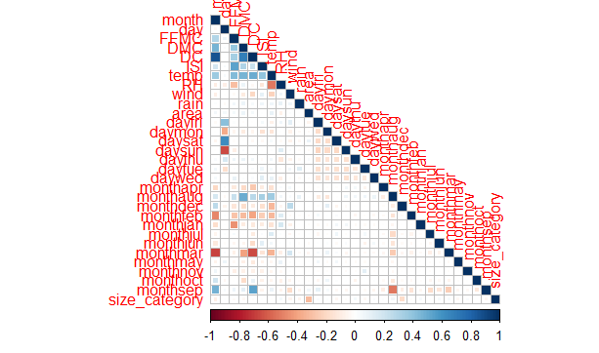

#Normalising

> norm <- function(x){

+ return((x-min(x))/(max(x)-min(x)))

+ }

>

> forest_norm <- as.data.frame(lapply(forest,norm))

> head(forest_norm)

month day FFMC DMC DC ISI temp RH

1 0.1818182 0.8333333 0.8709677 0.08649207 0.10132520 0.09090909 0.1929260 0.4235294

2 0.8181818 0.3333333 0.9277419 0.11819435 0.77541926 0.11942959 0.5080386 0.2117647

3 0.8181818 1.0000000 0.9277419 0.14679531 0.79629412 0.11942959 0.3987138 0.2117647

4 0.1818182 0.8333333 0.9419355 0.11095796 0.08162308 0.16042781 0.1961415 0.9647059

5 0.1818182 0.0000000 0.9109677 0.17298415 0.11058989 0.17112299 0.2958199 0.9882353

6 0.6363636 0.0000000 0.9496774 0.29014473 0.56303507 0.26203209 0.6430868 0.1647059

wind rain area dayfri daymon daysat daysun daythu daytue daywed monthapr

1 0.70000000 0.00000 0 1 0 0 0 0 0 0 0

2 0.05555556 0.00000 0 0 0 0 0 0 1 0 0

3 0.10000000 0.00000 0 0 0 1 0 0 0 0 0

4 0.40000000 0.03125 0 1 0 0 0 0 0 0 0

5 0.15555556 0.00000 0 0 0 0 1 0 0 0 0

6 0.55555556 0.00000 0 0 0 0 1 0 0 0 0

monthaug monthdec monthfeb monthjan monthjul monthjun monthmar monthmay monthnov

1 0 0 0 0 0 0 1 0 0

2 0 0 0 0 0 0 0 0 0

3 0 0 0 0 0 0 0 0 0

4 0 0 0 0 0 0 1 0 0

5 0 0 0 0 0 0 1 0 0

6 1 0 0 0 0 0 0 0 0

monthoct monthsep size_category

1 0 0 1

2 1 0 1

3 1 0 1

4 0 0 1

5 0 0 1

6 0 0 1

>

> #splitting of data to test and train

> set.seed(100)

> trns <- createDataPartition(forest_norm$area,p=0.8,list = F)

> tn <- forest_norm[trns,]

> ts <- forest_norm[-trns,]

>

> # Model building

>

> #rbfdot

> modelrbfdot <- ksvm(area~.,data=tn,kernel="rbfdot")

> predrbfdot <- predict(modelrbfdot,newdata=ts)

> cor(predrbfdot,ts$area)

[,1]

[1,] 0.3431461

plot(predrbfdot)

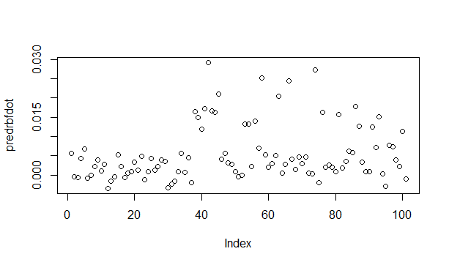

> #besseldot

> modelbessel <- ksvm(area~.,data=tn,kernel="besseldot")

Setting default kernel parameters

> predbessel <- predict(modelbessel,newdata=ts)

> cor(predbessel,ts$area)

[,1]

[1,] -0.04111227

> plot(predbessel)

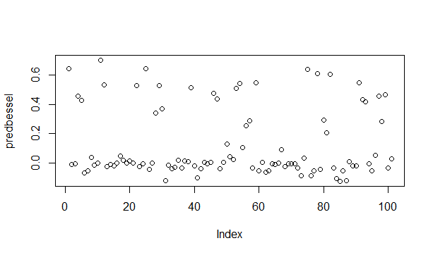

#ploydot

> modelpoly <- ksvm(area~.,data=tn,kernel="polydot")

Setting default kernel parameters

> predpoly <- predict(modelpoly,newdata=ts)

> cor(predpoly,ts$area) #acc = 0.3455455

[,1]

[1,] 0.3455455

> plot(predpoly)

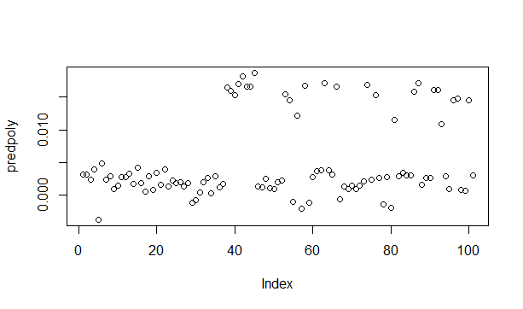

> #vanilladot

> modelvanilla <- ksvm(area~.,data=tn,kernel="vanilladot")

Setting default kernel parameters

> predvanilla <- predict(modelvanilla,newdata=ts)

> cor(predvanilla,ts$area) #acc = 0.3464077

[,1]

[1,] 0.3464077

> plot(predvanilla)

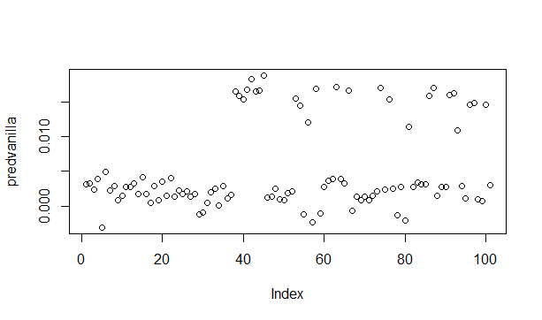

> #tanhdot

> modeltanh <- ksvm(area~.,data=tn,kernel="tanhdot")

Setting default kernel parameters

> predtanh <- predict(modeltanh,newdata=ts)

> cor(predtanh,ts$area)

[,1]

[1,] 0.005924511

> plot(predtanh)

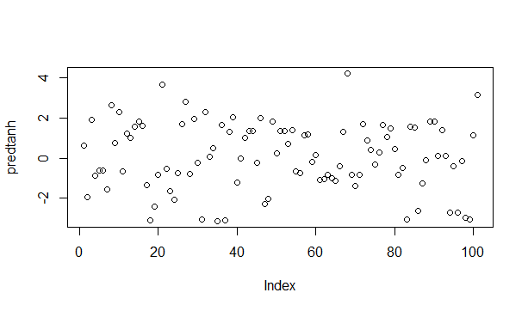

#anovadot

> modelanova <- ksvm(area~.,data=tn,kernel="anovadot")

Setting default kernel parameters

> predanova <- predict(modelanova,newdata=ts)

> cor(predanova,ts$area) #acc = 0.3368088

[,1]

[1,] 0.3368088

> plot(predanova)

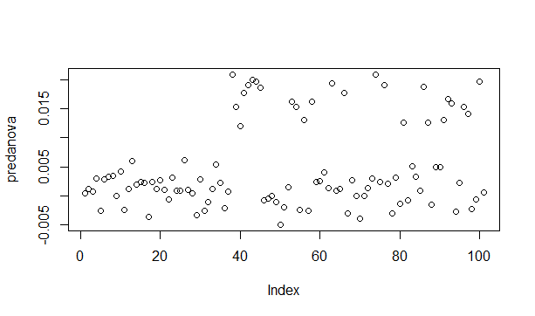

> #using bagging method

>

> kernels <- c("rbfdot","polydot","vanilladot","tanhdot","laplacedot","besseldot","anovadot")

> acc_bag <- list()

> pred_inf <- list()

> table_inf <- list()

> for(i in kernels){

+ model_bag <- ksvm(area~.,data=tn,kernel=i)

+ pred_bag <- predict(model_bag,ts)

+ pred_inf[[i]] <- pred_bag

+ acc_bag[[i]] <- (cor(pred_bag,ts$area))

+ table_inf <- table(pred_bag,ts$area)

+ }

Setting default kernel parameters

Setting default kernel parameters

Setting default kernel parameters

Setting default kernel parameters

Setting default kernel parameters

> acc_bag

$rbfdot

[,1]

[1,] 0.3464792

$polydot

[,1]

[1,] 0.3455455

$vanilladot

[,1]

[1,] 0.3464077

$tanhdot

[,1]

[1,] 0.005924511

$laplacedot

[,1]

[1,] 0.3447945

$besseldot

[,1]

[1,] -0.04111227

$anovadot

[,1]

[1,] 0.3368088

> pred_inf

$rbfdot

[,1]

[1,] 0.0055235381

[2,] 0.0002937640

[3,] -0.0003760850

[4,] 0.0043287864

[5,] 0.0063759245

[6,] -0.0003612238

[7,] 0.0002175055

[8,] 0.0024799374

[9,] 0.0039723575

[10,] 0.0009358707

[11,] 0.0026161601

[12,] -0.0033290073

[13,] -0.0006498956

[14,] 0.0002744147

[15,] 0.0050088581

[16,] 0.0027927009

[17,] -0.0001142374

[18,] 0.0009953393

[19,] 0.0008030128

[20,] 0.0034959706

[21,] 0.0012072462

[22,] 0.0049244166

[23,] -0.0009249317

[24,] 0.0008160039

[25,] 0.0042545117

[26,] 0.0013925864

[27,] 0.0023012753

[28,] 0.0039809844

[29,] 0.0035219106

[30,] -0.0031164448

[31,] -0.0013714528

[32,] -0.0009608787

[33,] 0.0012869451

[34,] 0.0054575072

[35,] 0.0010310670

[36,] 0.0043328459

[37,] -0.0012385130

[38,] 0.0163087120

[39,] 0.0150743722

[40,] 0.0119676593

[41,] 0.0174029636

[42,] 0.0275961634

[43,] 0.0164531512

[44,] 0.0162046302

[45,] 0.0207862993

[46,] 0.0039926947

[47,] 0.0054703392

[48,] 0.0032527619

[49,] 0.0028864316

[50,] 0.0012335796

[51,] -0.0002252932

[52,] 0.0001228827

[53,] 0.0135643713

[54,] 0.0137644245

[55,] 0.0019945898

[56,] 0.0137566718

[57,] 0.0059827745

[58,] 0.0244478746

[59,] 0.0045454028

[60,] 0.0022065884

[61,] 0.0030303802

[62,] 0.0049154407

[63,] 0.0199550872

[64,] 0.0009212730

[65,] 0.0029724095

[66,] 0.0235689314

[67,] 0.0041783826

[68,] 0.0014574975

[69,] 0.0044497293

[70,] 0.0028258480

[71,] 0.0044497293

[72,] 0.0005483527

[73,] 0.0004162945

[74,] 0.0260433219

[75,] -0.0024131621

[76,] 0.0162827235

[77,] 0.0016817110

[78,] 0.0022452980

[79,] 0.0016175337

[80,] 0.0006554819

[81,] 0.0148209618

[82,] 0.0019370744

[83,] 0.0035820943

[84,] 0.0059783846

[85,] 0.0057174662

[86,] 0.0176376460

[87,] 0.0128637612

[88,] 0.0033074890

[89,] 0.0011400065

[90,] 0.0011400065

[91,] 0.0129443262

[92,] 0.0076272717

[93,] 0.0144719952

[94,] 0.0010427072

[95,] -0.0027462668

[96,] 0.0080713413

[97,] 0.0071456248

[98,] 0.0039834170

[99,] 0.0018950316

[100,] 0.0115647642

[101,] -0.0008135634

$polydot

[,1]

[1,] 0.0031404284

[2,] 0.0031694065

[3,] 0.0024067740

[4,] 0.0039800649

[5,] -0.0037436841

[6,] 0.0048966557

[7,] 0.0023219207

[8,] 0.0029457450

[9,] 0.0009252305

[10,] 0.0014269010

[11,] 0.0027846140

[12,] 0.0027785908

[13,] 0.0032720581

[14,] 0.0017425865

[15,] 0.0041384591

[16,] 0.0018502824

[17,] 0.0005309239

[18,] 0.0028708699

[19,] 0.0008038895

[20,] 0.0034431975

[21,] 0.0015232738

[22,] 0.0039969024

[23,] 0.0013742752

[24,] 0.0022168141

[25,] 0.0018959263

[26,] 0.0019260818

[27,] 0.0013190722

[28,] 0.0017893829

[29,] -0.0011873377

[30,] -0.0007404387

[31,] 0.0004561062

[32,] 0.0020196203

[33,] 0.0026088395

[34,] 0.0002468642

[35,] 0.0028739254

[36,] 0.0011525288

[37,] 0.0016495999

[38,] 0.0165032380

[39,] 0.0159591515

[40,] 0.0152933455

[41,] 0.0169550515

[42,] 0.0182330934

[43,] 0.0165631393

[44,] 0.0165926191

[45,] 0.0187067002

[46,] 0.0013374135

[47,] 0.0011761730

[48,] 0.0024755159

[49,] 0.0010671831

[50,] 0.0009714035

[51,] 0.0019796607

[52,] 0.0022450955

[53,] 0.0154293416

[54,] 0.0145431673

[55,] -0.0010867666

[56,] 0.0121337814

[57,] -0.0020566709

[58,] 0.0168140528

[59,] -0.0011165366

[60,] 0.0027533699

[61,] 0.0036101334

[62,] 0.0038238525

[63,] 0.0170909486

[64,] 0.0038519557

[65,] 0.0031973323

[66,] 0.0166085319

[67,] -0.0006004827

[68,] 0.0013045422

[69,] 0.0008907037

[70,] 0.0013935637

[71,] 0.0008907037

[72,] 0.0014741774

[73,] 0.0021236788

[74,] 0.0169316308

[75,] 0.0023664037

[76,] 0.0153667427

[77,] 0.0026687829

[78,] -0.0014201868

[79,] 0.0027817965

[80,] -0.0019870912

[81,] 0.0115078924

[82,] 0.0028762409

[83,] 0.0033693214

[84,] 0.0030749026

[85,] 0.0030607474

[86,] 0.0158257312

[87,] 0.0171215495

[88,] 0.0015474027

[89,] 0.0026795636

[90,] 0.0026795636

[91,] 0.0161340457

[92,] 0.0161433709

[93,] 0.0109166371

[94,] 0.0028277624

[95,] 0.0009525602

[96,] 0.0144699329

[97,] 0.0147601889

[98,] 0.0008342827

[99,] 0.0006522579

[100,] 0.0145513002

[101,] 0.0029962131

$vanilladot

[,1]

3 0.0030953342

6 0.0032202877

9 0.0024211392

17 0.0039635673

23 -0.0030605316

29 0.0049717505

33 0.0022040282

34 0.0029365578

54 0.0008354381

57 0.0014710268

59 0.0027418070

61 0.0027319253

63 0.0032463419

66 0.0017156077

89 0.0041537438

96 0.0018021399

99 0.0005282377

101 0.0028614547

102 0.0008024271

109 0.0034936691

114 0.0015377671

117 0.0039754760

122 0.0013698235

125 0.0022888568

129 0.0017463726

136 0.0021206018

138 0.0013165776

147 0.0017150598

151 -0.0012231835

152 -0.0008839397

156 0.0004822501

170 0.0020153756

171 0.0025162825

172 0.0001076712

173 0.0028663213

175 0.0011324040

178 0.0015630098

186 0.0165002549

191 0.0158531209

195 0.0154065126

219 0.0168281872

232 0.0182541986

233 0.0165572292

238 0.0165764183

239 0.0187928037

242 0.0012000906

244 0.0013036590

246 0.0025656264

253 0.0010063642

262 0.0009068079

263 0.0018572896

264 0.0020859619

274 0.0155265031

281 0.0144640452

290 -0.0011521432

292 0.0120854280

293 -0.0022967323

312 0.0168433261

313 -0.0010951904

314 0.0027127299

318 0.0036555902

320 0.0038903101

322 0.0171080572

326 0.0039212492

329 0.0032335735

333 0.0166549889

336 -0.0006265536

344 0.0013189293

348 0.0008317168

350 0.0013352539

351 0.0008317168

364 0.0014529419

368 0.0021729953

369 0.0170217709

379 0.0023379651

382 0.0153244657

390 0.0025690541

400 -0.0013647419

403 0.0027071119

413 -0.0020643926

417 0.0114479235

418 0.0027406228

419 0.0033489051

429 0.0031752998

433 0.0031648807

434 0.0158422626

445 0.0170184353

449 0.0014685033

461 0.0027056095

462 0.0027056095

466 0.0160599347

470 0.0163015480

480 0.0108488792

483 0.0028923255

486 0.0011308309

489 0.0146588713

500 0.0148958296

501 0.0009282082

503 0.0007464311

505 0.0146448618

516 0.0030715023

$tanhdot

[,1]

[1,] 0.60631097

[2,] -1.92463884

[3,] 1.88352853

[4,] -0.87173844

[5,] -0.60767728

[6,] -0.62778272

[7,] -1.54531050

[8,] 2.62466603

[9,] 0.76777251

[10,] 2.26931641

[11,] -0.64403998

[12,] 1.22903759

[13,] 1.02715686

[14,] 1.58365761

[15,] 1.79862896

[16,] 1.62028866

[17,] -1.32941211

[18,] -3.10434179

[19,] -2.39128499

[20,] -0.82262439

[21,] 3.64308610

[22,] -0.52782739

[23,] -1.65366215

[24,] -2.06900784

[25,] -0.73847198

[26,] 1.68314813

[27,] 2.79076203

[28,] -0.78528784

[29,] 1.93806158

[30,] -0.21479380

[31,] -3.03457173

[32,] 2.29295173

[33,] 0.07019112

[34,] 0.48293907

[35,] -3.12060937

[36,] 1.64497466

[37,] -3.07866392

[38,] 1.31779982

[39,] 2.03887998

[40,] -1.19569566

[41,] -0.03767858

[42,] 1.00778139

[43,] 1.34104140

[44,] 1.34925571

[45,] -0.21859345

[46,] 1.97461141

[47,] -2.26393258

[48,] -2.03432059

[49,] 1.82731555

[50,] 0.24301520

[51,] 1.32988043

[52,] 1.34627873

[53,] 0.69690781

[54,] 1.38445820

[55,] -0.64679395

[56,] -0.72857750

[57,] 1.15393532

[58,] 1.19415505

[59,] -0.17203665

[60,] 0.14468229

[61,] -1.09073312

[62,] -1.01997362

[63,] -0.81417975

[64,] -0.99029699

[65,] -1.13732473

[66,] -0.42055073

[67,] 1.30165057

[68,] 4.20516913

[69,] -0.83689656

[70,] -1.38519220

[71,] -0.83689656

[72,] 1.69864806

[73,] 0.90071471

[74,] 0.39273163

[75,] -0.32573887

[76,] 0.27256223

[77,] 1.64422418

[78,] 1.05497766

[79,] 1.46283234

[80,] 0.46882829

[81,] -0.80972090

[82,] -0.50570881

[83,] -3.04228388

[84,] 1.56578908

[85,] 1.52946915

[86,] -2.63598850

[87,] -1.26210662

[88,] -0.10594928

[89,] 1.83026609

[90,] 1.83026609

[91,] 0.09660286

[92,] 1.41048429

[93,] 0.12825051

[94,] -2.68615795

[95,] -0.40815199

[96,] -2.69392362

[97,] -0.13636769

[98,] -2.97890910

[99,] -3.02781857

[100,] 1.13028033

[101,] 3.14285852

$laplacedot

[,1]

[1,] 0.004799411

[2,] 0.003646894

[3,] 0.003730901

[4,] 0.004272602

[5,] 0.005291165

[6,] 0.003959280

[7,] 0.003798523

[8,] 0.003919147

[9,] 0.003972695

[10,] 0.003747837

[11,] 0.004835629

[12,] 0.002043163

[13,] 0.003144959

[14,] 0.003182206

[15,] 0.004407260

[16,] 0.004275925

[17,] 0.003679925

[18,] 0.003903126

[19,] 0.003114233

[20,] 0.003976121

[21,] 0.003624801

[22,] 0.004889234

[23,] 0.003234373

[24,] 0.004260244

[25,] 0.004099897

[26,] 0.004259143

[27,] 0.003574031

[28,] 0.004297609

[29,] 0.004362079

[30,] 0.002293927

[31,] 0.003083151

[32,] 0.002711501

[33,] 0.003540409

[34,] 0.004103210

[35,] 0.003903053

[36,] 0.003985089

[37,] 0.003673086

[38,] 0.014902373

[39,] 0.013098387

[40,] 0.011970155

[41,] 0.014018320

[42,] 0.020542178

[43,] 0.014849567

[44,] 0.014683707

[45,] 0.016506160

[46,] 0.004288767

[47,] 0.004665268

[48,] 0.004098055

[49,] 0.003662001

[50,] 0.004292757

[51,] 0.003045996

[52,] 0.003333388

[53,] 0.014623410

[54,] 0.014793715

[55,] 0.003628836

[56,] 0.012413452

[57,] 0.003863396

[58,] 0.018527708

[59,] 0.004433231

[60,] 0.003951860

[61,] 0.003896952

[62,] 0.004627954

[63,] 0.016433973

[64,] 0.003828139

[65,] 0.004164903

[66,] 0.018615161

[67,] 0.003963587

[68,] 0.003605911

[69,] 0.004368733

[70,] 0.004101830

[71,] 0.004368733

[72,] 0.003572975

[73,] 0.003732208

[74,] 0.019224333

[75,] 0.002760686

[76,] 0.014789289

[77,] 0.003837352

[78,] 0.004010649

[79,] 0.003914748

[80,] 0.003268895

[81,] 0.012771180

[82,] 0.003548093

[83,] 0.004425928

[84,] 0.004753440

[85,] 0.004847499

[86,] 0.015582099

[87,] 0.013245187

[88,] 0.004489624

[89,] 0.003580240

[90,] 0.003580240

[91,] 0.011707615

[92,] 0.010426029

[93,] 0.012314513

[94,] 0.003766362

[95,] 0.003016895

[96,] 0.012420013

[97,] 0.006706952

[98,] 0.004004072

[99,] 0.003756598

[100,] 0.012370074

[101,] 0.002685648

$besseldot

[,1]

[1,] 0.6442893211

[2,] -0.0120471526

[3,] -0.0050274567

[4,] 0.4552435965

[5,] 0.4271981258

[6,] -0.0676642789

[7,] -0.0522626938

[8,] 0.0387673400

[9,] -0.0151143780

[10,] -0.0020539192

[11,] 0.7033011756

[12,] 0.5348220381

[13,] -0.0250642473

[14,] -0.0094952102

[15,] -0.0214094793

[16,] -0.0018487835

[17,] 0.0494993342

[18,] 0.0173102707

[19,] -0.0018941795

[20,] 0.0139759343

[21,] -0.0001290534

[22,] 0.5322568371

[23,] -0.0276872522

[24,] -0.0073198461

[25,] 0.6453632080

[26,] -0.0429988114

[27,] -0.0024317890

[28,] 0.3417865875

[29,] 0.5303235088

[30,] 0.3721271304

[31,] -0.1235673818

[32,] -0.0167461087

[33,] -0.0419236091

[34,] -0.0312219643

[35,] 0.0185714132

[36,] -0.0358007947

[37,] 0.0116038717

[38,] 0.0063642327

[39,] 0.5153847050

[40,] -0.0206687085

[41,] -0.1045094743

[42,] -0.0406483665

[43,] 0.0021890718

[44,] -0.0079957736

[45,] 0.0016951031

[46,] 0.4779185035

[47,] 0.4360776293

[48,] -0.0378122677

[49,] 0.0048024127

[50,] 0.1279768991

[51,] 0.0404387769

[52,] 0.0242716279

[53,] 0.5105754173

[54,] 0.5461202904

[55,] 0.1045553903

[56,] 0.2563934058

[57,] 0.2899966852

[58,] -0.0339680246

[59,] 0.5500859577

[60,] -0.0551126937

[61,] 0.0035415703

[62,] -0.0621184689

[63,] -0.0542662481

[64,] -0.0075151329

[65,] -0.0124349165

[66,] 0.0002327665

[67,] 0.0925775072

[68,] -0.0251376803

[69,] -0.0082259961

[70,] -0.0082201727

[71,] -0.0082259961

[72,] -0.0328506208

[73,] -0.0862232107

[74,] 0.0333856569

[75,] 0.6407666146

[76,] -0.0869449580

[77,] -0.0525073868

[78,] 0.6104384710

[79,] -0.0440013736

[80,] 0.2951422126

[81,] 0.2077039488

[82,] 0.6086613358

[83,] -0.0328954396

[84,] -0.1093042152

[85,] -0.1253245425

[86,] -0.0532622544

[87,] -0.1199264763

[88,] 0.0077004205

[89,] -0.0184911926

[90,] -0.0184911926

[91,] 0.5502655932

[92,] 0.4325946833

[93,] 0.4190043690

[94,] -0.0048952448

[95,] -0.0533494731

[96,] 0.0500912134

[97,] 0.4581440109

[98,] 0.2833374658

[99,] 0.4687881837

[100,] -0.0332471710

[101,] 0.0260957687

$anovadot

[,1]

[1,] 4.477724e-04

[2,] 1.126671e-03

[3,] 7.856084e-04

[4,] 2.976755e-03

[5,] -2.656789e-03

[6,] 2.816887e-03

[7,] 3.306113e-03

[8,] 3.450815e-03

[9,] -5.291098e-06

[10,] 4.219856e-03

[11,] -2.420306e-03

[12,] 1.150965e-03

[13,] 5.914158e-03

[14,] 1.854815e-03

[15,] 2.403579e-03

[16,] 2.176370e-03

[17,] -3.705840e-03

[18,] 2.431805e-03

[19,] 1.224132e-03

[20,] 2.709281e-03

[21,] 9.714958e-04

[22,] -6.730089e-04

[23,] 3.200575e-03

[24,] 8.783681e-04

[25,] 9.452351e-04

[26,] 6.193573e-03

[27,] 1.020439e-03

[28,] 3.487013e-04

[29,] -3.353593e-03

[30,] 2.886989e-03

[31,] -2.576135e-03

[32,] -1.109990e-03

[33,] 1.120007e-03

[34,] 5.444809e-03

[35,] 2.188921e-03

[36,] -2.146599e-03

[37,] 7.328647e-04

[38,] 2.081417e-02

[39,] 1.529305e-02

[40,] 1.199023e-02

[41,] 1.772208e-02

[42,] 1.901971e-02

[43,] 2.001792e-02

[44,] 1.961829e-02

[45,] 1.866643e-02

[46,] -8.191759e-04

[47,] -4.103746e-04

[48,] 5.418658e-06

[49,] -1.153848e-03

[50,] -4.949164e-03

[51,] -1.983280e-03

[52,] 1.407965e-03

[53,] 1.623313e-02

[54,] 1.528089e-02

[55,] -2.416497e-03

[56,] 1.307426e-02

[57,] -2.540432e-03

[58,] 1.619919e-02

[59,] 2.349939e-03

[60,] 2.554428e-03

[61,] 4.073352e-03

[62,] 1.307357e-03

[63,] 1.939764e-02

[64,] 8.096968e-04

[65,] 1.105187e-03

[66,] 1.776844e-02

[67,] -3.012648e-03

[68,] 2.638396e-03

[69,] 4.288436e-06

[70,] -3.950097e-03

[71,] 4.288436e-06

[72,] 1.249047e-03

[73,] 2.950816e-03

[74,] 2.085943e-02

[75,] 2.445988e-03

[76,] 1.912759e-02

[77,] 2.018384e-03

[78,] -3.010520e-03

[79,] 3.178131e-03

[80,] -1.375241e-03

[81,] 1.259741e-02

[82,] -7.685530e-04

[83,] 5.020993e-03

[84,] 3.313745e-03

[85,] 8.276804e-04

[86,] 1.874480e-02

[87,] 1.254175e-02

[88,] -1.520936e-03

[89,] 4.874649e-03

[90,] 4.874649e-03

[91,] 1.309699e-02

[92,] 1.667776e-02

[93,] 1.590367e-02

[94,] -2.760298e-03

[95,] 2.196392e-03

[96,] 1.523713e-02

[97,] 1.406391e-02

[98,] -2.250216e-03

[99,] -7.021697e-04

[100,] 1.966787e-02

[101,] 5.782045e-04

table_inf

pred_bag 0 0.000192512192438854 0.000696710791683473

-0.00494916421537237 0 0 0

-0.00395009666321595 0 0 0

-0.00370584043591032 1 0 0

-0.0033535929585179 0 0 0

-0.00301264823254317 1 0 0

-0.00301051992449853 1 0 0

-0.00276029825089222 0 0 0

-0.00265678864848265 1 0 0

-0.00257613474041047 0 0 0

-0.00254043199757569 0 0 0

-0.00242030559351765 1 0 0

-0.00241649673987384 1 0 0

-0.00225021605124961 1 0 0

-0.002146599159706 0 0 0

-0.00198328036861252 0 0 0

-0.00152093552290393 1 0 0

-0.00137524060449213 0 0 0

-0.00115384819322509 0 1 0

-0.00110999039662769 0 0 0

pred_bag 0.000870888489604342 0.00109090242382018 0.00118257489641011

-0.00494916421537237 0 0 0

-0.00395009666321595 0 0 0

-0.00370584043591032 0 0 0

-0.0033535929585179 0 1 0

-0.00301264823254317 0 0 0

-0.00301051992449853 0 0 0

-0.00276029825089222 0 0 1

-0.00265678864848265 0 0 0

-0.00257613474041047 0 0 0

-0.00254043199757569 0 0 0

-0.00242030559351765 0 0 0

-0.00241649673987384 0 0 0

-0.00225021605124961 0 0 0

-0.002146599159706 0 0 0

-0.00198328036861252 0 0 0

-0.00152093552290393 0 0 0

-0.00137524060449213 0 0 0

-0.00115384819322509 0 0 0

-0.00110999039662769 0 0 0

pred_bag 0.00124674562722306 0.00143009057240292 0.00149426130321587

-0.00494916421537237 0 0 0

-0.00395009666321595 0 0 0

-0.00370584043591032 0 0 0

-0.0033535929585179 0 0 0

-0.00301264823254317 0 0 0

-0.00301051992449853 0 0 0

-0.00276029825089222 0 0 0

-0.00265678864848265 0 0 0

-0.00257613474041047 0 1 0

-0.00254043199757569 0 0 0

-0.00242030559351765 0 0 0

-0.00241649673987384 0 0 0

-0.00225021605124961 0 0 0

-0.002146599159706 0 0 0

-0.00198328036861252 0 0 0

-0.00152093552290393 0 0 0

-0.00137524060449213 0 0 1

-0.00115384819322509 0 0 0

-0.00110999039662769 0 0 0

pred_bag 0.00150342855047486 0.00189762018261157 0.00199845990246049

-0.00494916421537237 0 0 0

-0.00395009666321595 1 0 0

-0.00370584043591032 0 0 0

-0.0033535929585179 0 0 0

-0.00301264823254317 0 0 0

-0.00301051992449853 0 0 0

-0.00276029825089222 0 0 0

-0.00265678864848265 0 0 0

-0.00257613474041047 0 0 0

-0.00254043199757569 0 0 0

-0.00242030559351765 0 0 0

-0.00241649673987384 0 0 0

-0.00225021605124961 0 0 0

-0.002146599159706 0 0 0

-0.00198328036861252 0 0 0

-0.00152093552290393 0 0 0

-0.00137524060449213 0 0 0

-0.00115384819322509 0 0 0

-0.00110999039662769 0 0 0

pred_bag 0.00223680833119431 0.00233764805104323 0.00235598254556122

-0.00494916421537237 0 0 0

-0.00395009666321595 0 0 0

-0.00370584043591032 0 0 0

-0.0033535929585179 0 0 0

-0.00301264823254317 0 0 0

-0.00301051992449853 0 0 0

-0.00276029825089222 0 0 0

-0.00265678864848265 0 0 0

-0.00257613474041047 0 0 0

-0.00254043199757569 0 0 0

-0.00242030559351765 0 0 0

-0.00241649673987384 0 0 0

-0.00225021605124961 0 0 0

-0.002146599159706 0 0 0

-0.00198328036861252 0 0 0

-0.00152093552290393 0 0 0

-0.00137524060449213 0 0 0

-0.00115384819322509 0 0 0

-0.00110999039662769 0 1 0

pred_bag 0.00242015327637417 0.00246598951266914 0.0025118257489641

-0.00494916421537237 0 0 0

-0.00395009666321595 0 0 0

-0.00370584043591032 0 0 0

-0.0033535929585179 0 0 0

-0.00301264823254317 0 0 0

-0.00301051992449853 0 0 0

-0.00276029825089222 0 0 0

-0.00265678864848265 0 0 0

-0.00257613474041047 0 0 0

-0.00254043199757569 1 0 0

-0.00242030559351765 0 0 0

-0.00241649673987384 0 0 0

-0.00225021605124961 0 0 0

-0.002146599159706 0 0 0

-0.00198328036861252 0 0 0

-0.00152093552290393 0 0 0

-0.00137524060449213 0 0 0

-0.00115384819322509 0 0 0

-0.00110999039662769 0 0 0

pred_bag 0.00268600344688497 0.00302519159546771 0.00320853654064757

-0.00494916421537237 0 1 0

-0.00395009666321595 0 0 0

-0.00370584043591032 0 0 0

-0.0033535929585179 0 0 0

-0.00301264823254317 0 0 0

-0.00301051992449853 0 0 0

-0.00276029825089222 0 0 0

-0.00265678864848265 0 0 0

-0.00257613474041047 0 0 0

-0.00254043199757569 0 0 0

-0.00242030559351765 0 0 0

-0.00241649673987384 0 0 0

-0.00225021605124961 0 0 0

-0.002146599159706 0 0 1

-0.00198328036861252 0 0 0

-0.00152093552290393 0 0 0

-0.00137524060449213 0 0 0

-0.00115384819322509 0 0 0

-0.00110999039662769 0 0 0

pred_bag 0.00340104873308643 0.00346521946389938 0.00389608008507205

-0.00494916421537237 0 0 0

-0.00395009666321595 0 0 0

-0.00370584043591032 0 0 0

-0.0033535929585179 0 0 0

-0.00301264823254317 0 0 0

-0.00301051992449853 0 0 0

-0.00276029825089222 0 0 0

-0.00265678864848265 0 0 0

-0.00257613474041047 0 0 0

-0.00254043199757569 0 0 0

-0.00242030559351765 0 0 0

-0.00241649673987384 0 0 0

-0.00225021605124961 0 0 0

-0.002146599159706 0 0 0

-0.00198328036861252 0 0 1

-0.00152093552290393 0 0 0

-0.00137524060449213 0 0 0

-0.00115384819322509 0 0 0

-0.00110999039662769 0 0 0

pred_bag 0.00404275604121594 0.00429943896446775 0.00627039712515126

-0.00494916421537237 0 0 0

-0.00395009666321595 0 0 0

-0.00370584043591032 0 0 0

-0.0033535929585179 0 0 0

-0.00301264823254317 0 0 0

-0.00301051992449853 0 0 0

-0.00276029825089222 0 0 0

-0.00265678864848265 0 0 0

-0.00257613474041047 0 0 0

-0.00254043199757569 0 0 0

-0.00242030559351765 0 0 0

-0.00241649673987384 0 0 0

-0.00225021605124961 0 0 0

-0.002146599159706 0 0 0

-0.00198328036861252 0 0 0

-0.00152093552290393 0 0 0

-0.00137524060449213 0 0 0

-0.00115384819322509 0 0 0

-0.00110999039662769 0 0 0

pred_bag 0.00643540757581313 0.00645374207033112 0.006609585273734

-0.00494916421537237 0 0 0

-0.00395009666321595 0 0 0

-0.00370584043591032 0 0 0

-0.0033535929585179 0 0 0

-0.00301264823254317 0 0 0

-0.00301051992449853 0 0 0

-0.00276029825089222 0 0 0

-0.00265678864848265 0 0 0

-0.00257613474041047 0 0 0

-0.00254043199757569 0 0 0

-0.00242030559351765 0 0 0

-0.00241649673987384 0 0 0

-0.00225021605124961 0 0 0

-0.002146599159706 0 0 0

-0.00198328036861252 0 0 0

-0.00152093552290393 0 0 0

-0.00137524060449213 0 0 0

-0.00115384819322509 0 0 0

-0.00110999039662769 0 0 0

pred_bag 0.00733379780719446 0.00761798247222324 0.00823218803857578

-0.00494916421537237 0 0 0

-0.00395009666321595 0 0 0

-0.00370584043591032 0 0 0

-0.0033535929585179 0 0 0

-0.00301264823254317 0 0 0

-0.00301051992449853 0 0 0

-0.00276029825089222 0 0 0

-0.00265678864848265 0 0 0

-0.00257613474041047 0 0 0

-0.00254043199757569 0 0 0

-0.00242030559351765 0 0 0

-0.00241649673987384 0 0 0

-0.00225021605124961 0 0 0

-0.002146599159706 0 0 0

-0.00198328036861252 0 0 0

-0.00152093552290393 0 0 0

-0.00137524060449213 0 0 0

-0.00115384819322509 0 0 0

-0.00110999039662769 0 0 0

pred_bag 0.00849803820908658 0.0091305782699571 0.00917641450625206

-0.00494916421537237 0 0 0

-0.00395009666321595 0 0 0

-0.00370584043591032 0 0 0

-0.0033535929585179 0 0 0

-0.00301264823254317 0 0 0

-0.00301051992449853 0 0 0

-0.00276029825089222 0 0 0

-0.00265678864848265 0 0 0

-0.00257613474041047 0 0 0

-0.00254043199757569 0 0 0

-0.00242030559351765 0 0 0

-0.00241649673987384 0 0 0

-0.00225021605124961 0 0 0

-0.002146599159706 0 0 0

-0.00198328036861252 0 0 0

-0.00152093552290393 0 0 0

-0.00137524060449213 0 0 0

-0.00115384819322509 0 0 0

-0.00110999039662769 0 0 0

pred_bag 0.0099189615342305 0.0102856514245902 0.0115874005353672

-0.00494916421537237 0 0 0

-0.00395009666321595 0 0 0

-0.00370584043591032 0 0 0

-0.0033535929585179 0 0 0

-0.00301264823254317 0 0 0

-0.00301051992449853 0 0 0

-0.00276029825089222 0 0 0

-0.00265678864848265 0 0 0

-0.00257613474041047 0 0 0

-0.00254043199757569 0 0 0

-0.00242030559351765 0 0 0

-0.00241649673987384 0 0 0

-0.00225021605124961 0 0 0

-0.002146599159706 0 0 0

-0.00198328036861252 0 0 0

-0.00152093552290393 0 0 0

-0.00137524060449213 0 0 0

-0.00115384819322509 0 0 0

-0.00110999039662769 0 0 0

pred_bag 0.0130999963331011 0.0140625572952954 0.0149701147739357

-0.00494916421537237 0 0 0

-0.00395009666321595 0 0 0

-0.00370584043591032 0 0 0

-0.0033535929585179 0 0 0

-0.00301264823254317 0 0 0

-0.00301051992449853 0 0 0

-0.00276029825089222 0 0 0

-0.00265678864848265 0 0 0

-0.00257613474041047 0 0 0

-0.00254043199757569 0 0 0

-0.00242030559351765 0 0 0

-0.00241649673987384 0 0 0

-0.00225021605124961 0 0 0

-0.002146599159706 0 0 0

-0.00198328036861252 0 0 0

-0.00152093552290393 0 0 0

-0.00137524060449213 0 0 0

-0.00115384819322509 0 0 0

-0.00110999039662769 0 0 0

pred_bag 0.029078508305526 0.0428110446994976 0.0454603791573466

-0.00494916421537237 0 0 0

-0.00395009666321595 0 0 0

-0.00370584043591032 0 0 0

-0.0033535929585179 0 0 0

-0.00301264823254317 0 0 0

-0.00301051992449853 0 0 0

-0.00276029825089222 0 0 0

-0.00265678864848265 0 0 0

-0.00257613474041047 0 0 0

-0.00254043199757569 0 0 0

-0.00242030559351765 0 0 0

-0.00241649673987384 0 0 0

-0.00225021605124961 0 0 0

-0.002146599159706 0 0 0

-0.00198328036861252 0 0 0

-0.00152093552290393 0 0 0

-0.00137524060449213 0 0 0

-0.00115384819322509 0 0 0

-0.00110999039662769 0 0 0

pred_bag 0.0560393824942246 0.087253859411096 0.0947801694107294

-0.00494916421537237 0 0 0

-0.00395009666321595 0 0 0

-0.00370584043591032 0 0 0

-0.0033535929585179 0 0 0

-0.00301264823254317 0 0 0

-0.00301051992449853 0 0 0

-0.00276029825089222 0 0 0

-0.00265678864848265 0 0 0

-0.00257613474041047 0 0 0

-0.00254043199757569 0 0 0

-0.00242030559351765 0 0 0

-0.00241649673987384 0 0 0

-0.00225021605124961 0 0 0

-0.002146599159706 0 0 0

-0.00198328036861252 0 0 0

-0.00152093552290393 0 0 0

-0.00137524060449213 0 0 0

-0.00115384819322509 0 0 0

-0.00110999039662769 0 0 0

pred_bag 0.195152359649444 0.255335337904734 1

-0.00494916421537237 0 0 0

-0.00395009666321595 0 0 0

-0.00370584043591032 0 0 0

-0.0033535929585179 0 0 0

-0.00301264823254317 0 0 0

-0.00301051992449853 0 0 0

-0.00276029825089222 0 0 0

-0.00265678864848265 0 0 0

-0.00257613474041047 0 0 0

-0.00254043199757569 0 0 0

-0.00242030559351765 0 0 0

-0.00241649673987384 0 0 0

-0.00225021605124961 0 0 0

-0.002146599159706 0 0 0

-0.00198328036861252 0 0 0

-0.00152093552290393 0 0 0

-0.00137524060449213 0 0 0

-0.00115384819322509 0 0 0

-0.00110999039662769 0 0 0

[ reached getOption("max.print") -- omitted 80 rows ]

> acc_bagg <- data.frame(kernels,acc_bag)

> ggplot(data = acc_bagg)+

+ geom_col(mapping=aes(x=1:7,y=acc_bag))

